# *Synchro Boy* Teacher Guide

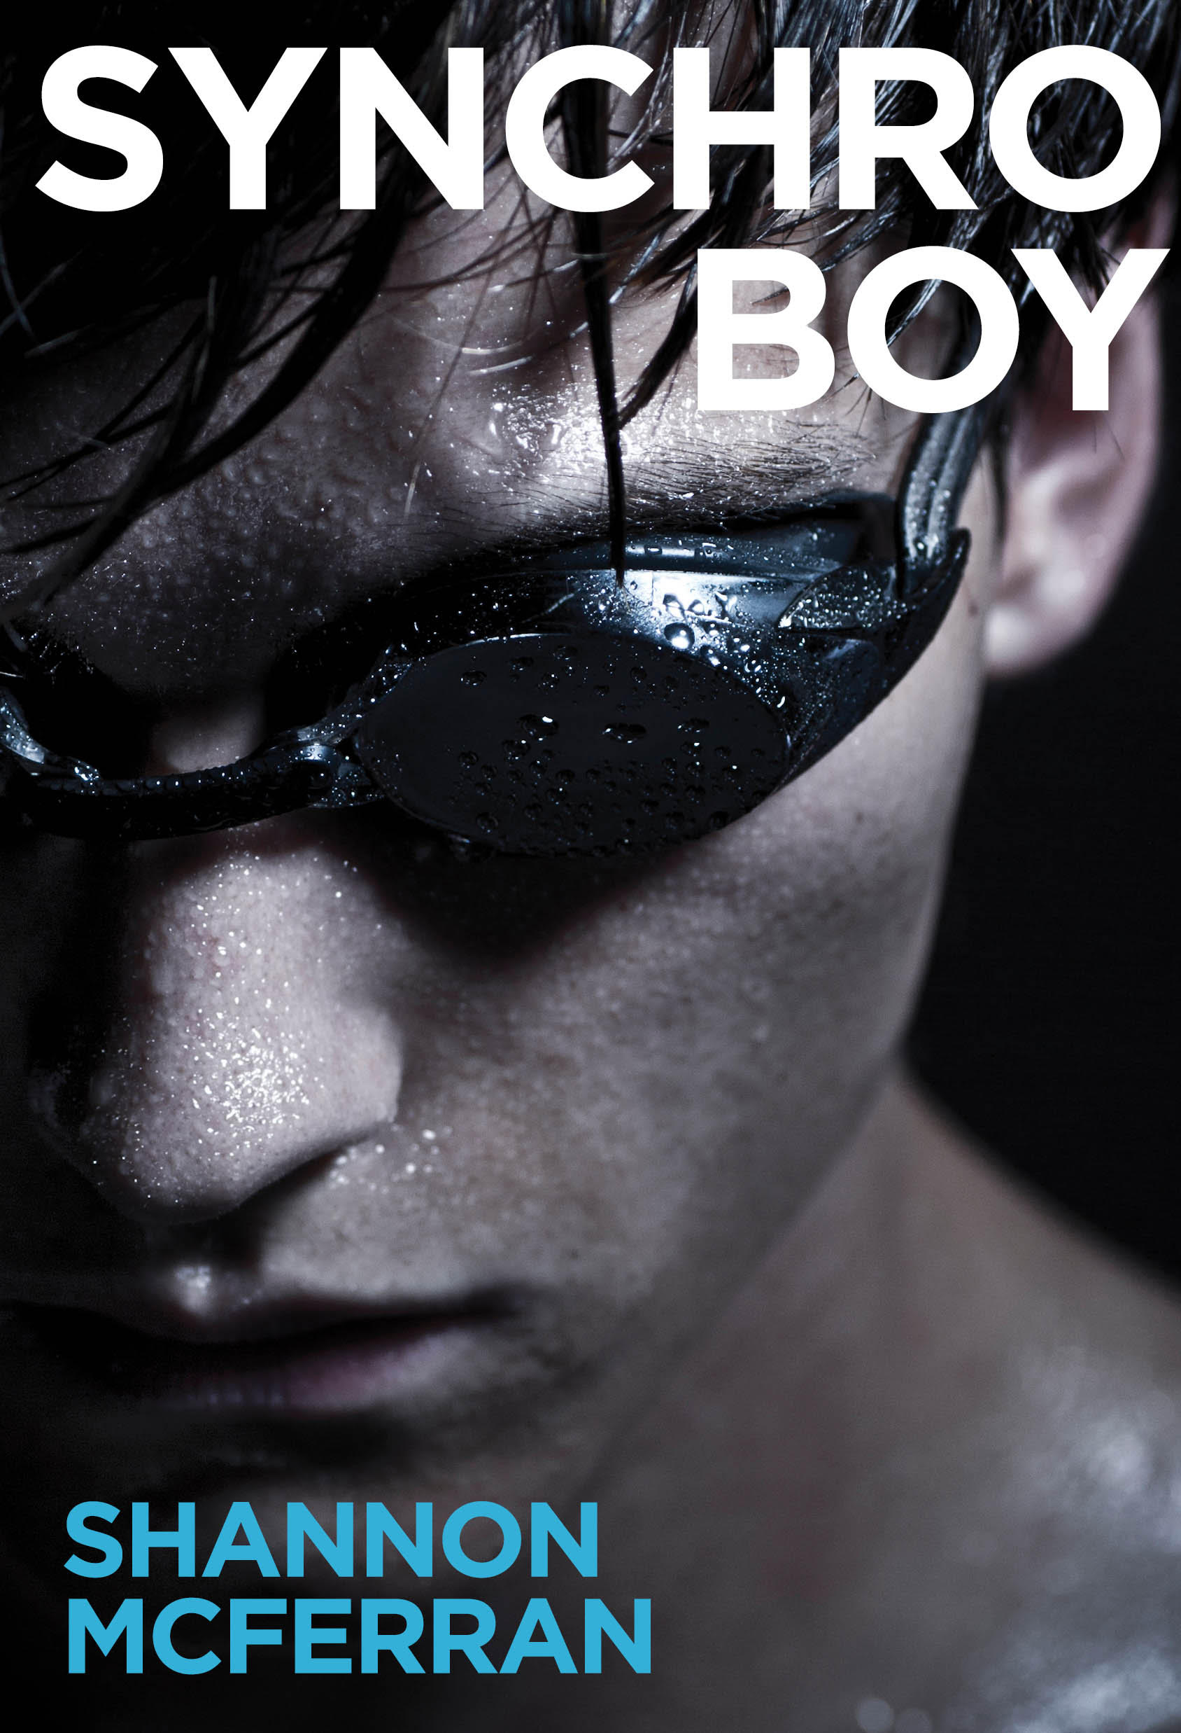

**NOTE:**

**This Teacher’s Guide is a work in progress! Rather than wait until everything is ready, I’m taking an agile approach and sharing this beta release with whole book discussions and project descriptions, as well as a quick overview of the book. Please come back for updated versions of the Guide as I add chapter discussion questions and quizzes, and complete curriculum alignment descriptions.**

This guide contains:

Book Overview: Character, Setting, and Plot overview

Note to the Teacher

Whole book discussion/essay questions

End of Book Activities

Proficiency Scales for Activity Assessment

Chapter discussion questions - TBD

Chapter quizzes - TBD

Quiz answer keys - TBD

BC Curriculum Alignment

Ontario Curriculum Alignment

Common Core English Language Arts 11/12 Standards Alignment - TBD

*Synchro Boy* is an evaluated resource in British Columbia. See the ERAC review of the novel

<https://k12.bcerac.ca/resource/?q=Synchro-Boy&ResourceTitleID=8929>

Synchro Boy has been nominated for a White Pine Award. Visit <http://www.accessola.org/web/OLA/Forest_of_Reading/OLA/Forest_of_Reading/Forest_of_Reading.aspx> for information on how to participate in this exciting reader’s choice award program.

Shannon McFerran may be available for in-person author visits/ writing workshops and Skype/Facetime chats. Contact her at shannon.mcferran@gmail.com.

## Praise for Synchro Boy

“Bart's eventual acceptance that he is bisexual gives him the confidence to lean into synchro while easing off on the need to validate his own masculinity through sporting achievements. A nuanced, compassionate exploration of male   
sexuality and identity.”—*[Kirkus](https://www.kirkusreviews.com/book-reviews/shannon-mcferran/synchro-boy/" \t "_blank)*  
  
Come on in, readers; the water’s fine.

— Michael Cart, *[Booklist](https://www.booklistonline.com/Synchro-Boy-Shannon-McFerran/pid=9703139" \t "_blank)*

4/5 stars - Highly Recommended

“There is a lot to appreciate in Synchro Boy, particularly the fact that, even though there is a “coming out” of sorts, the novel is not in and of itself a coming out story. The considerations of masculinity and femininity and the spaces in between is also refreshing. Anyone who has struggled to exist as feminine or masculine outside of traditionally prescribed assumptions in society will respect Bart’s journey and find much to sympathize with. Synchro Boy would certainly be worth including in classroom or school libraries.“ — Dr. Rob Bittner,*[Canadian Review of Materials](https://www.cmreviews.ca/node/120" \t "_blank)*

"This novel has a strong, fully developed male protagonist. Teens who are struggling with their sense of identity and family issues will relate to the burgeoning romances and the drawn-out emotional conflict between Bart and his father. The secondary characters are less fleshed out than Bart and Erika, but young people will still want to pick up the book.   
VERDICT: An excellent addition to YA shelves."

*[School Library Journal](https://www.slj.com/?reviewDetail=synchro-boy" \t "_blank)*

## Book Overview

### Characters

**Protagonist: Bart Lively: 16**

**Rosa Waves Swim Team:**

Coach Dennis Cragg

Riley Fletcher: Bart’s best friend

Andy

Geoff

**Rosa Pacific Synchro Club:**

Coach: Su-Yun (Sunny) Zhang

Erika Tenaka: Bart’s duet partner

Chelsea Gates: Erika’s former duet partner

Julia Sanford

Kyoka Shiozaki

Casey Bryant

Huiyan Jang

**Others:**

Melanie Lively: Bart’s Mom

Mike Lively: Bart’s Dad

Amanda Gates – Chelsea’s Mom

Ms. Shiozaki – Kyoka’s Mom

Dave Crawley aka “Dive Boy” – fellow student and a Dive Club member

Bill May: Bart’s hero, USA competitive synchronized swimmer, barred from the Olympics in 2004 due to his gender. May was a gold medalist at the inaugural Mixed Duet competition at the FINA World Championships, 2015.

### A Note About Setting

Synchro Boy takes place in a real place, on the traditional territory of the W̱SÁNEĆ, Lekwungen and Songhees Peoples. The characters live in the city of Victoria, on Vancouver Island, British Columbia. The pool and clubs that swim there in the story, however, are fictional—as is Rosa Pacific Secondary School.

The Rosa Waves Synchro club goes to Richmond, BC for a competition, and to Quebec City for the national event. But most of the action takes place at the Rosa Pacific Swimming Pool, Bart’s home, and his school.

### Plot Synopsis

BART LIVELY, a sixteen year old racing swimmer bound for the Olympics, desperately wants to feel like himself again. He loves the water, but he sure misses the freedom and expression he enjoyed when he was a dancer, and felt at home in his skin. He decides to try a free synchro session in the next pool, and it’s more than fun—it’s a challenge that captures him body and soul—*and* there’s a routine for guys: the mixed duet, just included in international competition last year.

ERIKA TENAKA, one of the club’s star swimmers, wants him to practice a mixed duet with her. But Bart’s already fighting off the guys on his team who harass Bart for being gay—something even *he’s* not sure of. If he joined *synchro*, it would only get worse. So Bart refuses, but when he finds out about the men who are fighting the sport’s gender stereotyping to compete in mixed duets around the world and get the event included in the 2020 Olympics, Bart feels compelled to join Erika.

To get the mixed duet ready for the ladder of competition ahead of them, Bart must master the technical aspects of synchro. He’s also falling for Erika, but he can’t seem to shake this ongoing flirtation with a guy in the dive club. And now, Erika’s jealous former duet partner CHELSEA wants Bart out of the club, until she realizes the attention the pair will get for entering the new event—attention she wants for herself. After passing a figures test and swimming at the Provincial competition, Bart gets together with Erika, spending romantic mornings hiding out at the top of the dive tower.

Then his coach splits Bart’s training time between Erika and Chelsea. Bart’s synchro improves with Chelsea’s technical influence, but they get a little too comfortable with each other, and end up kissing after a practice. Bart instantly regrets his slip—even before Erika sees, and refuses to swim her duet with him at the Qualifier. Devastated, Bart swims with Chelsea at the Qualifier. But none of the other mixed pairs show up, so they win by default, and the event is cancelled for the National competition. Tired of trying to master synchro the way Chelsea does—all perfectionism and no joy—Bart turns down her offer to come train with her as she gets ready for the Junior Worlds.

Tired too of trying to master his sexuality, Bart returns home and finally makes out with the boy from the dive club. But he isn’t in love with him—and while Bart knows he could love a guy in the future, he loves Erika in the *now*. So he tells her, and tries to convince Erika to swim with him again, hoping to feel the same joy he did before he started his quest for perfection. She says she’s retiring, but Bart’s secretly sent video of their performances to the federation that runs international competitions, who invites them to demo the mixed duet at the Western Open.

Bart begs Erika to take advantage of the opportunity. Up on the dive tower, he faces his fear of heights to prove that he’ll do anything to be her partner and work toward their Olympic dream together. Erika admits she’s scared about what lies ahead, but that she wants it too—and they leap off the tower together, side by side.

Swimming at the Western Open, they switch the boost so Erika lifts Bart for their big highlight—flipping the gender stereotype on its head, to loud applause from the stands. In the end, Bart knows he’s right where he should be: showing the world there’s more than one way to be a boy.

## Note to the Teacher:

Thank you for your interest in reading *Synchro Boy* with your students! If you have feedback on this resource or a request for a change or addition to the guide, please direct your message to shannon.mcferran@gmail.com.

**A note about First Peoples representation**

Synchro Boy reflects the diversity seen in real clubs and competition in British Columbia during the mid 2010s. There is racial diversity, yet none of the characters in the novel are Indigenous. This may spark a discussion with your students about what this says about access to sport for Indigenous youth, or preferences that Indigenous youth have for types of activities outside of school.